|  |  |  |
| --- | --- | --- |
| **AB1601 Organizational Behavior & Design**  **Critical Thinking Assignment Summary Page** | | |
| **Your name: Joel Tan** | | |
| **Your Instructor: Don Willis** | | |
| **Seminar Group: T16 Word count: 1083** | | |
| Provide a summary, ***in bulleted-form in the space provided*** ***within this page***, the content of your write-up in addressing the various criteria in the critical thinking rubric. | | |
| **Criteria** | **Your main points** | |
| 1. Define the subject matter, identify the key concepts and map their relationships | * Successful coalitions exercise moral leadership [P1] * Successful coalitions operate at the speed of trust [P2] * Leaders of high-impact coalitions must find a balance of commitments [P3] * Organisations must navigate competing coalitions [P4] * Successful high-impact coalitions focus on solutions [P5] | |
| 2. Identifies and considers OTHER theoretical perspectives that are important to the analysis of the issue | * High-impact coalitions must be of an appropriate size and consist of a suitable combination of members with relevant resources or capabilities [P6] * High-impact coalitions should be able to act on multiple scales [P7] | |
| 3. Identifies and assesses the quality of supporting data/evidence and provides additional data/evidence related to the issue | * P1 is accurate and relevant and can be further supported by the actions of WSU in 2017. * The evidence to support P5 is weak but can be strengthened by bringing in C19HHC’s actual actions in 2017. * P7 is a strong argument and can be further discussed by the looking at coalitions that operate on the local level. | |
| 4. Identifies and considers key assumptions and the influence of context on the issue | * The author assumes in P1 that that an inspiring purpose is what attracts members to join and contribute towards the objectives of a coalition. * The author assumes in P2 that trust between coalition members is the key reason for the success of the coalitions mentioned in the article. * In P3, the author assumes that it is sufficient for leaders of coalitions to understand their members’ capabilities and request for contributions respectively. | |
| 5. Provides a conclusion that discusses implications of the article and gives an informed, overall evaluation | * High-impact coalitions should exercise moral leadership but cannot rely on it solely to attract members. * Leaders of coalitions must keep in mind that trust and the balancing of commitments are hard to measure and manage. * High-impact coalitions should approach problems on multiple scales to generate solutions that target all parts of a problem. | |
| **Checklist** | 1. **Summary page ____** 2. **900- to 1100-Words Essay ___** 3. **List of References ____** | 1. **Self-assessed Critical Thinking Rubric ______** 2. **Signed Declaration of Integrity _____** |

**(Note: Please keep your summary to one page only)**.

|  |
| --- |
| ***Declaration of Integrity***  ***Nanyang Business School*** |

|  |  |
| --- | --- |
| ***Name:*** | **Joel Tan** |
| ***Matriculation No:*** | U2122877C |
| ***Course and Code:*** | Organizational Behavior & Design, AB1601 |
| ***Instructor:*** | Don Willis |
| ***Submission Date:*** | 24 February 2023 |

**Keep a Copy of the Assignment**

Please keep a copy of your work. If you submit your assignment electronically, please keep a backup copy.

**Plagiarism and Collusion**

**Plagiarism:** To pass off as your own the writings or ideas of another without acknowledging the sources from which the ideas are taken.

**Collusion:** To submit an assignment, project, or report done by another person, and to pass it off as your own (as defined in the *NTU Honour Code*. See <https://www.ntu.edu.sg/wkwsci/admissions/useful-links/undergraduate/academic-integrity> for the University Honor Code and Pledge).

***Penalties for Plagiarism and Collusion***

The penalties associated with plagiarism exist to reward good academic conduct. Those who cheat will be severely punished to reflect the seriousness with which NTU views cheating, and the university’s commitment to academic integrity. Penalties may include: the requirement to revise and resubmit an assignment, receiving a lower grade, or receiving an F grade for the assignment.

|  |
| --- |
| ***Declaration***  I declare that this assignment is my own work, unless otherwise referenced, as defined by the NTU policy on plagiarism. I have read the NTU Honour Code and Pledge. <https://www.ntu.edu.sg/wkwsci/admissions/useful-links/undergraduate/academic-integrity>  **Signed: Shape, arrow  Description automatically generated Dated: 24 February 2023** |

1. *Write a 1000 (+/- 10%) word critique of the article (1.5 line spacing, 12 font size).*
2. *Do not include the words in your concept maps and your reference list in your word count.*
3. *Document your references diligently by following the APA referencing format.*
4. *Complete the self-assessment.*

===================================================================

Write your critique here.

**AB1601 CRITICAL THINKING ASSIGNMENT**

Subject Matter & Key Concepts

Successful coalitions exercise moral leadership [P1], attracting followers with an inspiring purpose, while also maintaining tangible goals. Successful coalitions also operate at the speed of trust [P2], since the eventual speed and effectiveness of action is dependent on how quickly members can build trust with each other. Leaders of high-impact coalitions must also find a balance of commitments [P3], analysing the resources and capabilities their members possess and setting goals and roles respectively. Organisations must also navigate competing coalitions [P4] to ensure that their resources are not expended towards too many directions, and that sufficient attention can be focused on the objectives of each coalition. Lastly, successful high-impact coalitions focus on solutions [P5], allowing them to stay open to learning from others and exploring new possibilities.

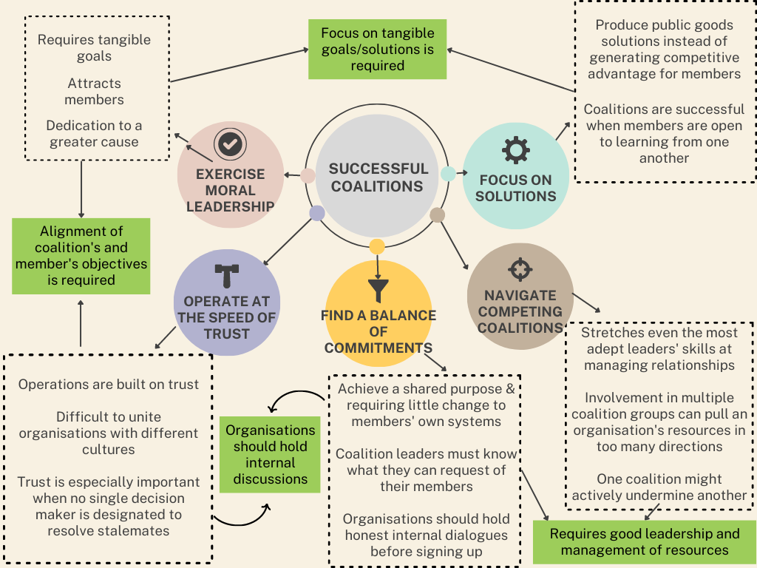

**Figure 1: Concept Map of *Creating High-Impact Coalitions***

Other Perspectives

To be effective, high-impact coalitions must also be of an appropriate size and consist of a suitable combination of members with relevant resources or capabilities [P6] (University of York, n.d.). Members of a coalition should possess expertise relevant to the tasks at hand or be able to effectively contribute towards the objectives of the coalition.

In addition, high-impact coalitions should also be able to act on multiple scales (Tattersall, n.d.) [P7]. Most issues cannot be solved at a single scale, and coalitions of varying scales can be created to tackle the individual roots of the issue on local, regional, state, national and international levels. There is never a one-size-fits-all way to tackle an issue, and coalitions that are able to effect change on multiple scales are more likely to identify and work on all the aspects of a problem.

Quality of the Evidence

P1 is supported with an example about how the initiators of West Side United (WSU), in recruiting members from other hospitals, made it clear that they were not acting for the benefit of Rush but were instead focused on addressing inequalities. The evidence presented to support P1 is accurate and relevant and can be further supported by the actions of WSU in 2017. Apart from simply “making clear” that they were focused on a greater, moral cause, WSU even hosted “Community Conversations” – events that allowed them to hold conversations with residents and community leaders – to obtain feedback and “hear more voices from the community”. They hosted a total of 21 Community Conversations, involving more than 330 residents and community leaders. Additionally, WSU – which was then still based at Rush University Medical Centre – published an informative report providing updates on the problems they were trying to solve, how they wanted to improve health equity on the West Side, and a consolidation of the shared ideas and feedback they had received during their initial meeting with stakeholders and during their conversations with the community (Rush University Medical Centre, 2017). Thus, it is evident how invested WSU was in understanding the magnitude of the problem, and how they had a clearly established purpose and dedication to a greater cause. Therefore, this further supports P1 as WSU’s use of moral leadership is unquestionably exhibited.

In P5, the author argues that coalitions can focus on solutions by collaborating with partner companies to “tap creativity, find innovations, and fill gaps”. However, he supports this weakly by mentioning how “C19HCC did the same with its large-scale telehealth impact studies”. However, the evidence provided only presents the results that the Covid-19 Healthcare Coalition (C19HCC) produced and is insufficient to prove that solutions can be found through collaborative work. In reality, the Telehealth Impact Study was formed through leadership from Mayo Clinic, MITRE Corporation, and other partners. In addition, the findings of the study were also a result of surveys conducted on healthcare professionals and patients (C19HCC Telehealth Impact Study Work Group, 2021). Thus, with further evidence, it can be seen that coalitions can generate the solutions they need through joint efforts between members and contributions by other stakeholders.

P7 is a strong argument and can be further discussed by the looking at coalitions that operate on the local level. The Ontario Health Coalition is a network of over 400 grassroots community organizations in Ontario, Canada that works towards the provision of healthcare and policy information to members of the public (Ontario Health Coalition, n.d.). It established 40 coalitions around the province, and ran a campaign that to collect hundreds of thousands of petitions and then move issues in a coordinated way across the province. These local town based coalitions were led by union members, retired teachers and community activists, providing a space for organizational members to build their skills and capacity to campaign (Tattersall, n.d.). Working on problems on a local scale has its own benefits, as community leaders are more aware of the social, political, and cultural factors that could affect how successful programs and strategies turn out to be (Odede, 2023). This shows how high-impact coalitions do not necessarily have to operate on a large global scale, and that it is important and effective to focus on other scales of action as well.

Key Assumptions

The author assumes in P1 that that an inspiring purpose is what attracts members to join and contribute towards the objectives of a coalition. However, members may also join a coalition if benefits can be reaped by contributing the objectives of the coalition. For example, a business that operates with sustainable practices contributes towards saving the environment – but at the same time, reduces business costs by improving operational efficiency, improves brand reputation and provides a competitive advantage (Maryville University, n.d.).

In the examples used by the author to support P2, he assumes that trust between coalition members is the key reason for the success of the coalitions mentioned in the article. However, trust between members of a coalition is also something that is intangible and unmeasurable, and the eventual cooperation between these members could have also been a result of other factors like profit and relationship-building.

In P3, the author assumes that it is sufficient for leaders of coalitions to understand their members’ capabilities and request for contributions respectively. However, this also boils down to the managerial capabilities of each member. Apart from managing the deployment of their employees, members also must estimate and manage their own finances and contributions to the coalition.

Conclusion

Overall, after considering the weight and validity of all perspectives, it is evident that high-impact coalitions should exercise moral leadership – but cannot rely solely on it to attract members. Although trust between members and the balancing of commitments are important too, leaders of coalitions must keep in mind that these factors are hard to measure and manage, and come up with measures to encourage these behaviours. Lastly, high-impact coalitions should approach problems on multiple scales to generate solutions that target all levels of a problem.

**References**

Kanter, & Hayirli, T. C. (2022). *Creating High-Impact Coalitions*. Harvard Business Review, 1–.

University of York. (n.d.). *What makes a successful coalition?* <https://www.york.ac.uk/news-and-events/features/successful-coalition/>

Tattersall, A. (n.d.) *Five Principles for Building Powerful Coalitions.* The Commons. <https://commonslibrary.org/five-principles-for-building-powerful-coalitions/>

Rush University Medical Centre. (2017, July). *What We Heard*. <https://www.rush.edu/sites/default/files/2020-09/what-we-heard-july-2017(3).pdf>

The COVID-19 Healthcare Coalition Telehealth Impact Study Work Group. (2021, May 7). *COVID-19 TELEHEALTH IMPACT STUDY.* Covid-19 Healthcare Coalition. <https://c19hcc.org/telehealth/>

Ontario Health Coalition. (n.d.) Ontario Health Coalition Facebook Page. <https://www.facebook.com/ontariohealth/>

Odede, K. (2023, January 27). *Wake up, Davos … global leaders must think local to solve the world’s problems.* The Guardian. <https://www.theguardian.com/global-development/2023/jan/27/wake-up-davos-global-leaders-must-think-local-to-solve-the-worlds-problems>

Maryville University. (n.d.). *The Importance of Environmental Awareness When Running a Business*. <https://online.maryville.edu/blog/importance-of-environmental-awareness-when-running-a-business/#:~:text=You%20can%20earn%20more%20money,of%20money%20sustainable%20businesses%20earn>.

**Critical Thinking Rubric for Self-assessment Name: Joel Tan______ Seminar Group: T16**

|  |  |  |  |  |  |
| --- | --- | --- | --- | --- | --- |
| **Observable traits** | **Weigh-tage (%)** | **1-4 Poor** | **5-7 Average** | **8-10 Good** | **Please rate your own assignment** |
| 1. Defines the subject matter, identifies key concepts and maps their relationships | 20% | Does not define the subject matter or identify the key concepts; fails to map the concepts in a logical manner | Defines the subject matter well, identifies nearly all the key concepts, and maps their relationships with one another somewhat logically | Defines the subject matter very well; identifies all the key concepts and maps their relationships with one another logically | 10 |
| 1. Identifies and considers OTHER theoretical perspectives that are important to the analysis of the issue | 20% | Deals only with a single perspective and fails to discuss other possible perspectives, especially those salient to the issue | Develops a better understanding of the issue by discussing other perspectives drawn from outside sources | Develops a comprehensive understanding of the issue by discussing other perspectives drawn from outside sources | 10 |
| 3. Identifies and assesses the quality of supporting data/evidence and provides additional data/evidence related to the issue | 20% | Fails to examine the validity of the information provided or provide justification for rejecting arguments provided. Confuses associations and correlations with cause and effect | Examines some of the evidence and source of evidence; questions its accuracy, precision, relevance, and completeness. Observes cause and effect and addresses existing or potential consequences | Examines the evidence and source of evidence; questions its accuracy, precision, relevance, and completeness. Observes cause and effect and addresses existing or potential consequences | 10 |
| 4. Identifies and considers key assumptions and the influence of the context on the issue | 20% | Does not consider the assumptions of the author, and does not examine the contexts | Identifies and questions the validity of some assumptions made by the author and analyzes the issue with some sense of scope and context | Identifies and questions the validity of assumptions made by the author, and analyzes the issue with a clear sense of scope and context | 10 |
| 5. Provides a conclusion that discusses implications of the article and gives an informed, overall evaluation | 20% | Fails to provide a conclusion, or provides a conclusion that is inconsistently tied to earlier discussion | Provides a conclusion that discusses some implications of the article and gives a good synthesis of the main points discussed | Provides a conclusion that logically discusses implications of the article, and gives an informed and well thought-out overall evaluation | 10 |